Figuring Board Feet - Application
120 Points (10 points per question) You need the diagram to complete the second page
You need to figure out how many board feet are needed for each piece, and how many board feet would be needed to build the entire project. Answer the following question.
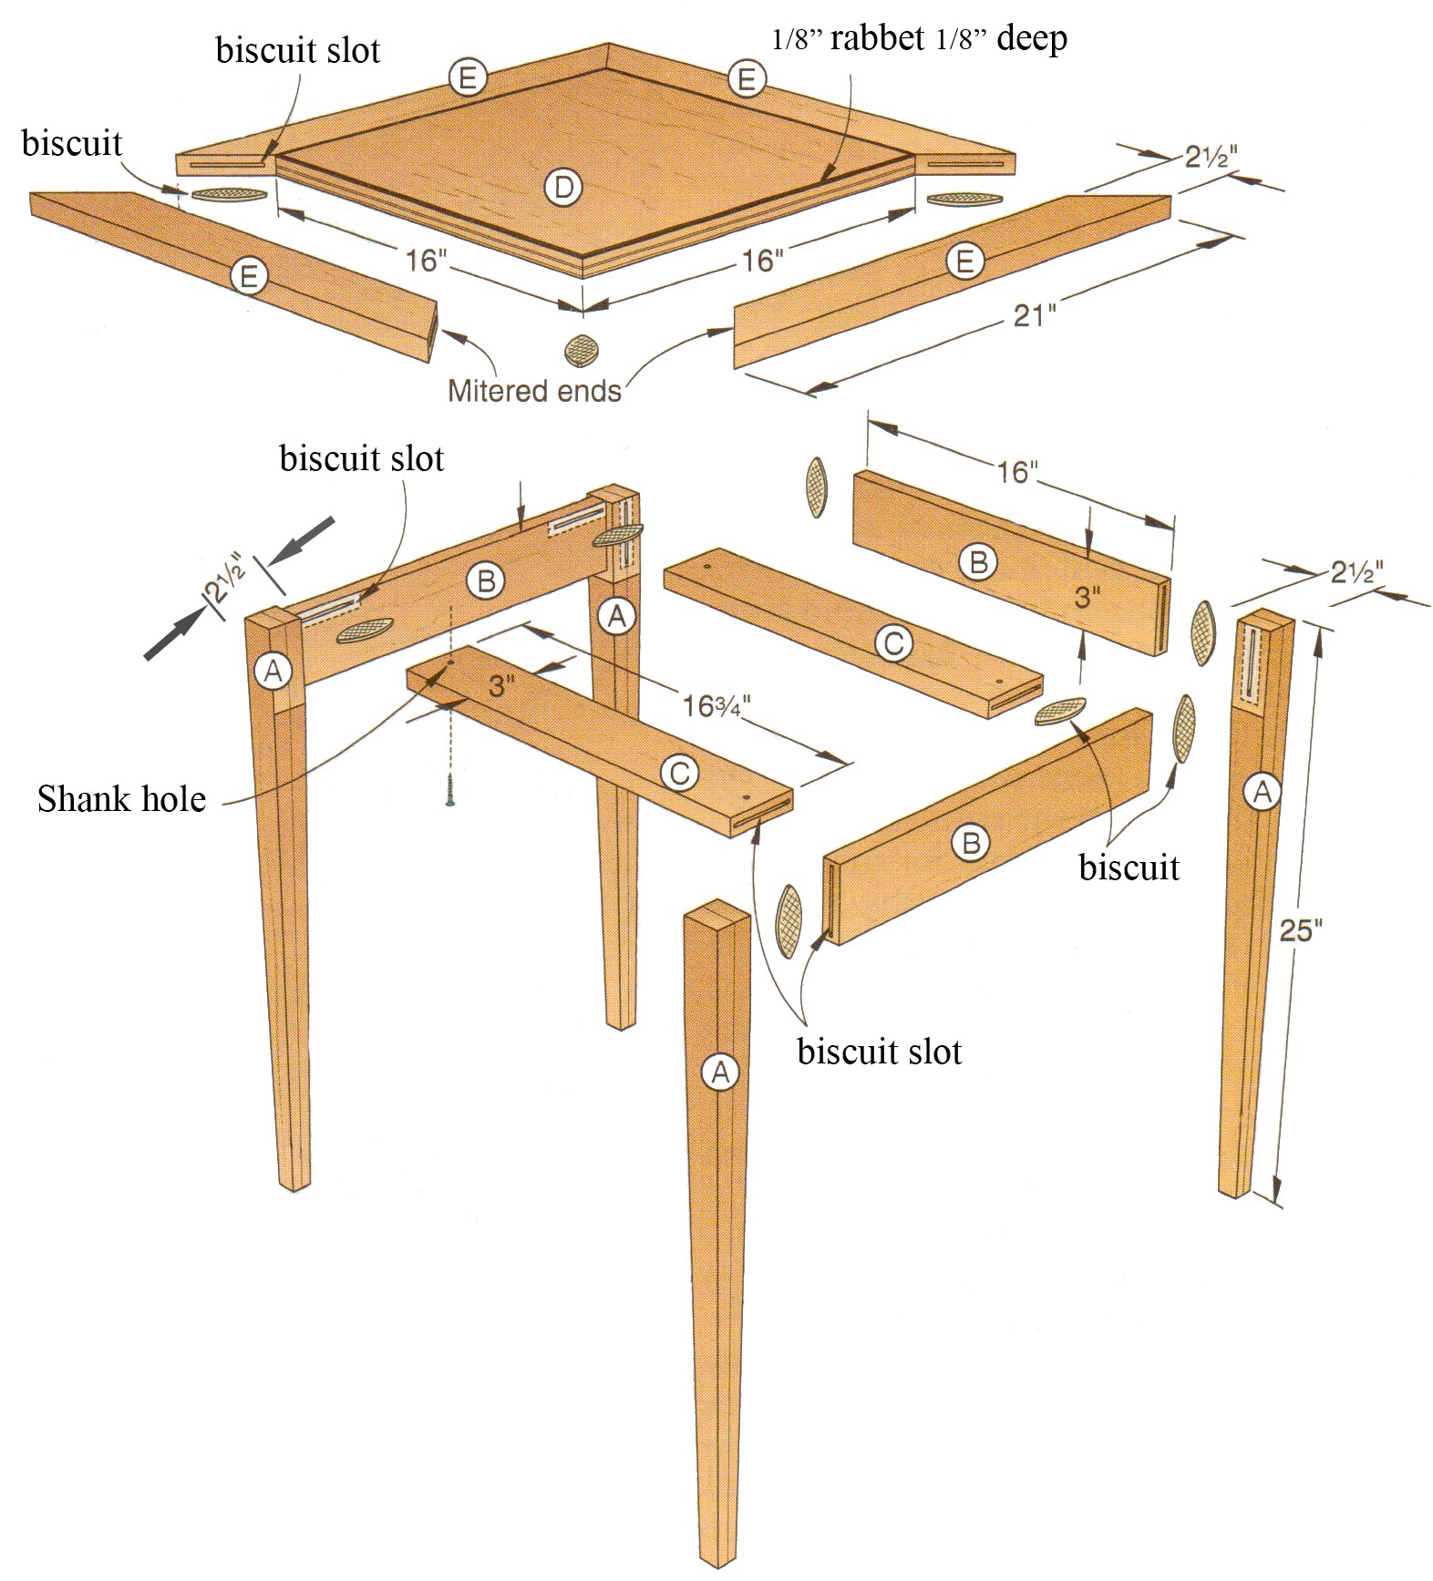

See Back Side

Name:_____________________________________

Figuring Board Worksheet
120 pts

You need to figure out how many board feet are needed for each piece. Answer the following question. Each piece is solid lumber. All stock is 1” thick unless plans specify. Round all answers to two decimal places.

1. Fill in the measurements for part A? _______” Long X ____________” Wide X __________” Thick
~ Look at all 4 legs to find all of the dimensions (sizes) needed.
2. How many Board Feet are in one Part A ? |  | ____________ Board Feet
3. How many Board Feet are needed for all 4 of Part A ?  ~ use you answer from above to calculate this question |  | ____________ Board Feet
4. How many Board Feet are Needed for one Part B? |  | ____________ Board Feet
5. How many Board Feet are needed for all 3 of Part B ?  ~ use you answer from above to calculate this question |  | ____________ Board Feet
6. How many Board Feet are Needed for one Part C? |  | ____________ Board Feet
7. How many Board Feet are needed for 2 of Part C ?  ~ use you answer from above to calculate this question |  | ____________ Board Feet
8. How many Board Feet are needed for Part D ?  Figure part D as solid lumber |  | ____________ Board Feet
9. How many Board Feet are needed for all 4 of Part E? |  | ____________ Board Feet
10. How many Board Feet are needed for the entire project ?  ~ Round up to the Nearest whole Board Feet |  | ____________ Board Feet

- If Solid Oak is $2.55 a Board Foot. How much would it cost to build this project?
~ use you answer from above to calculate this question

$ ___________________

- How many liner inches of 2-1/2” wood is needed for this project ___________________ feet

